LAB 03: Return to libc Attack
Name: S M AHSANUL KABIR

Task 1: Demonstration of using gcc with "execstack" and "noexecstack" options
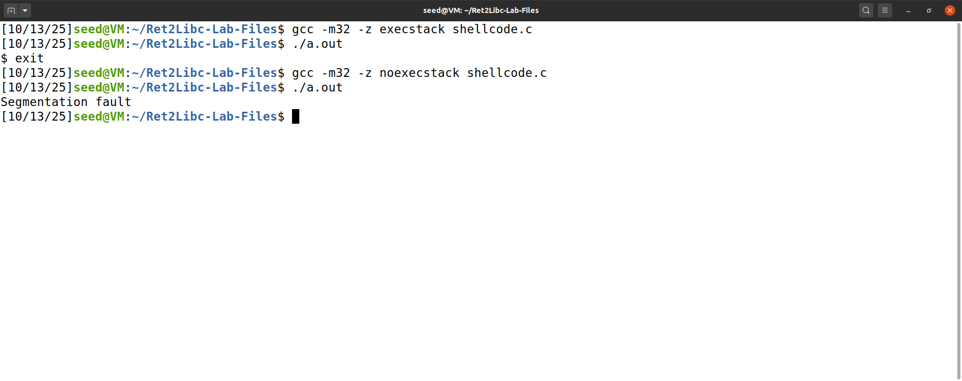

Task 2: Disable "virtual address space layout randomization (ASLR)" feature in Ubuntu
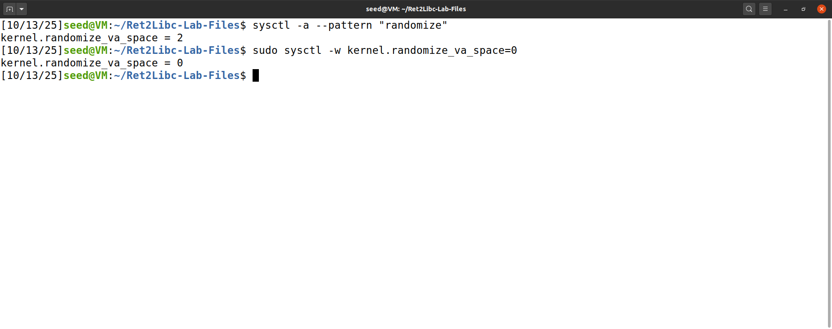

Task 3: Compile the vulnerable program in retlib.c and make it a root-owned Set-UID program (with stack guard on and non-executable stack)
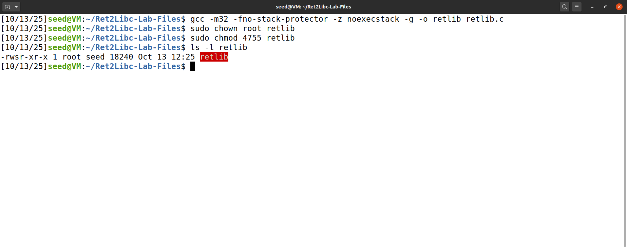

Task 4: Find the address of system() and exit() functions loaded from the libc library.
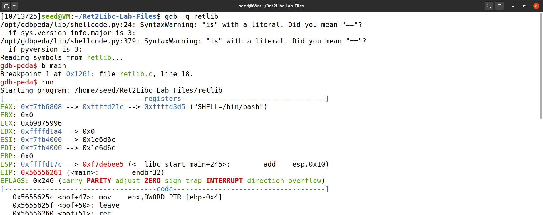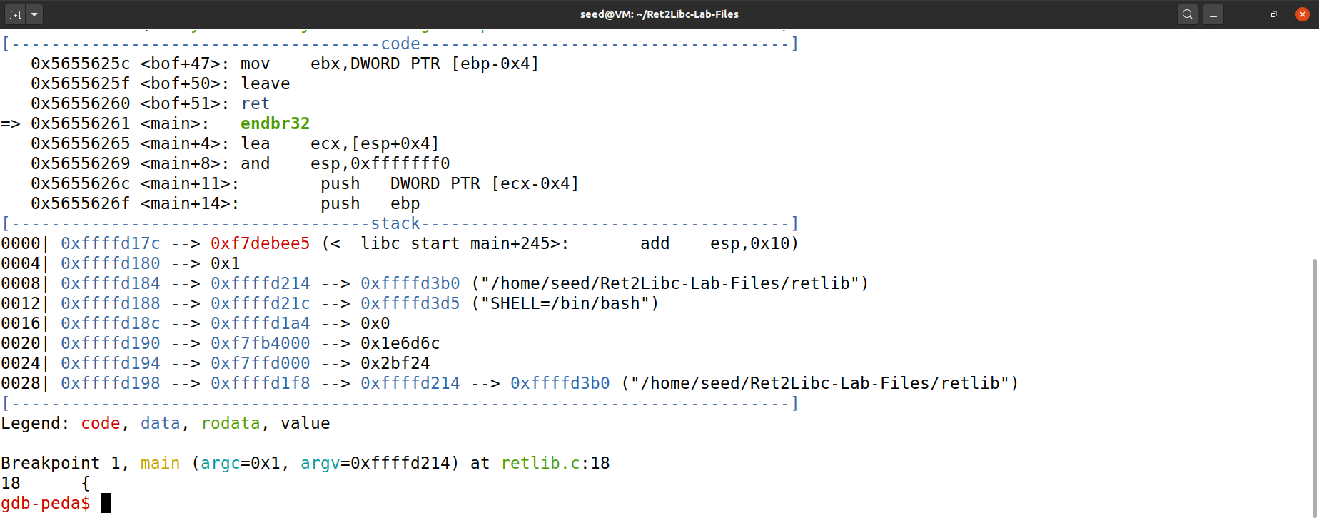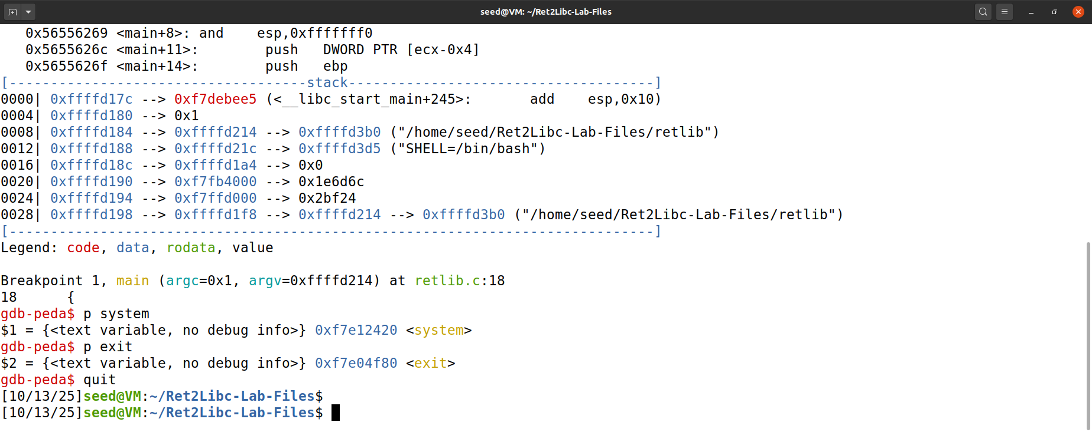

Task 5: Export a shell variable named MYSHELL with value "/bin/sh" (so it is available as an environment variable to programs/processes run from that shell).
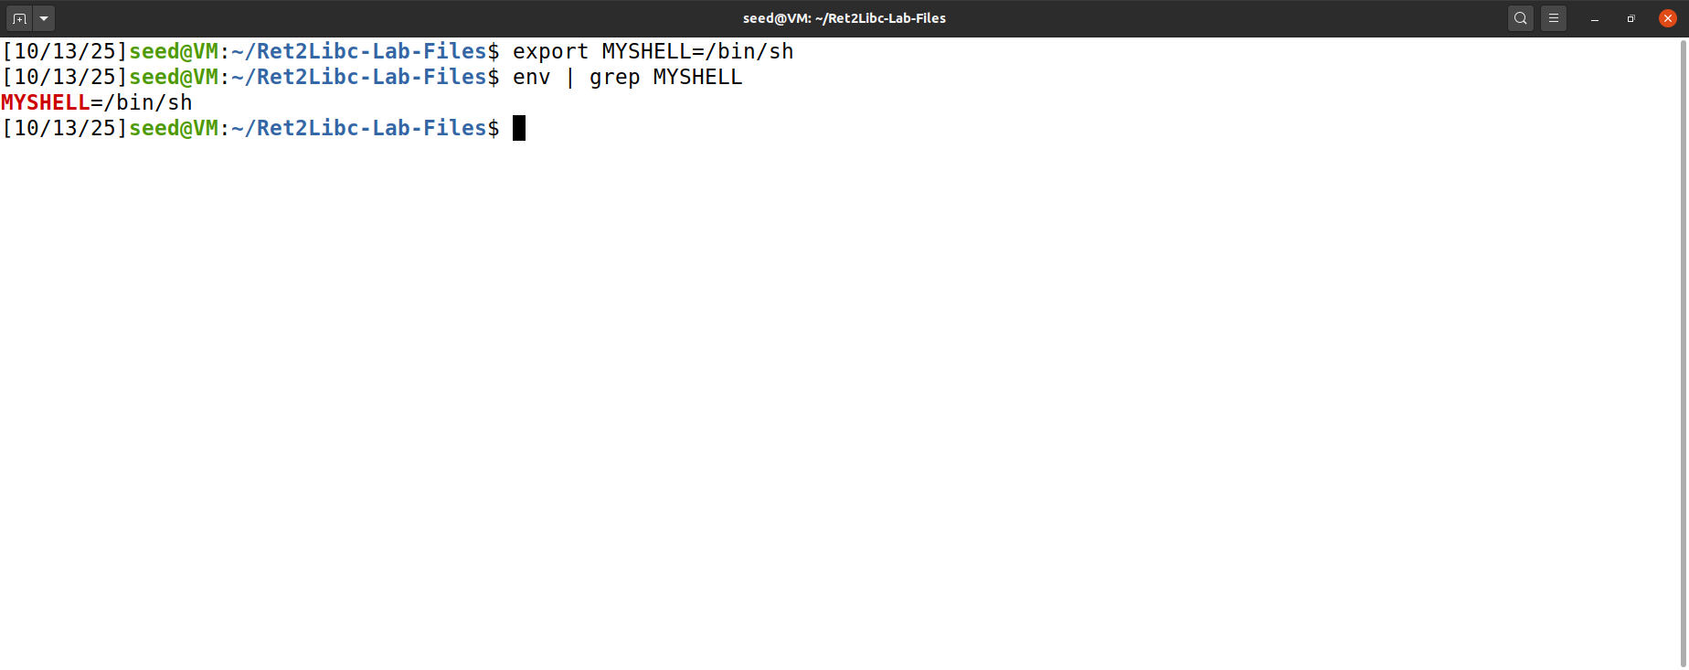

Task 6: Find the address of environment variable MYSHELL using the program in prnenv.c
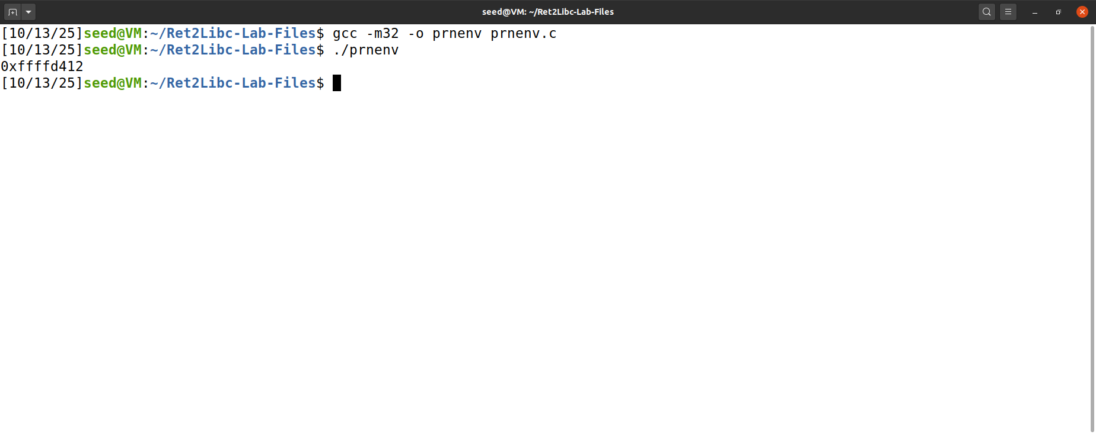

Task 7: Using gdb debugger, find the distance between buffer[] and ebp when the execution enters the bof() function in retlib.c
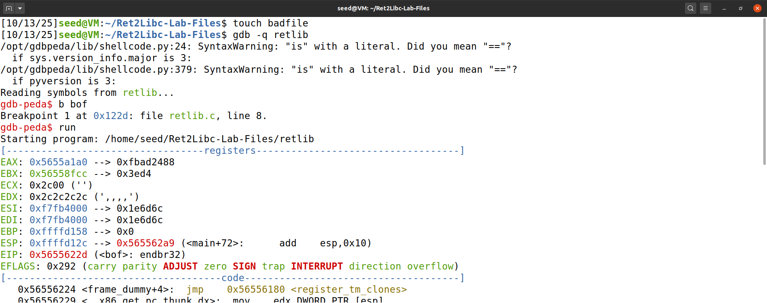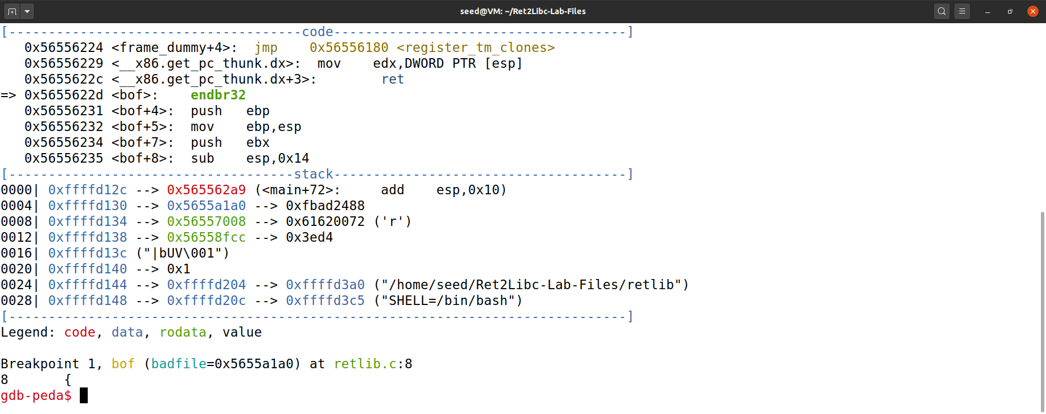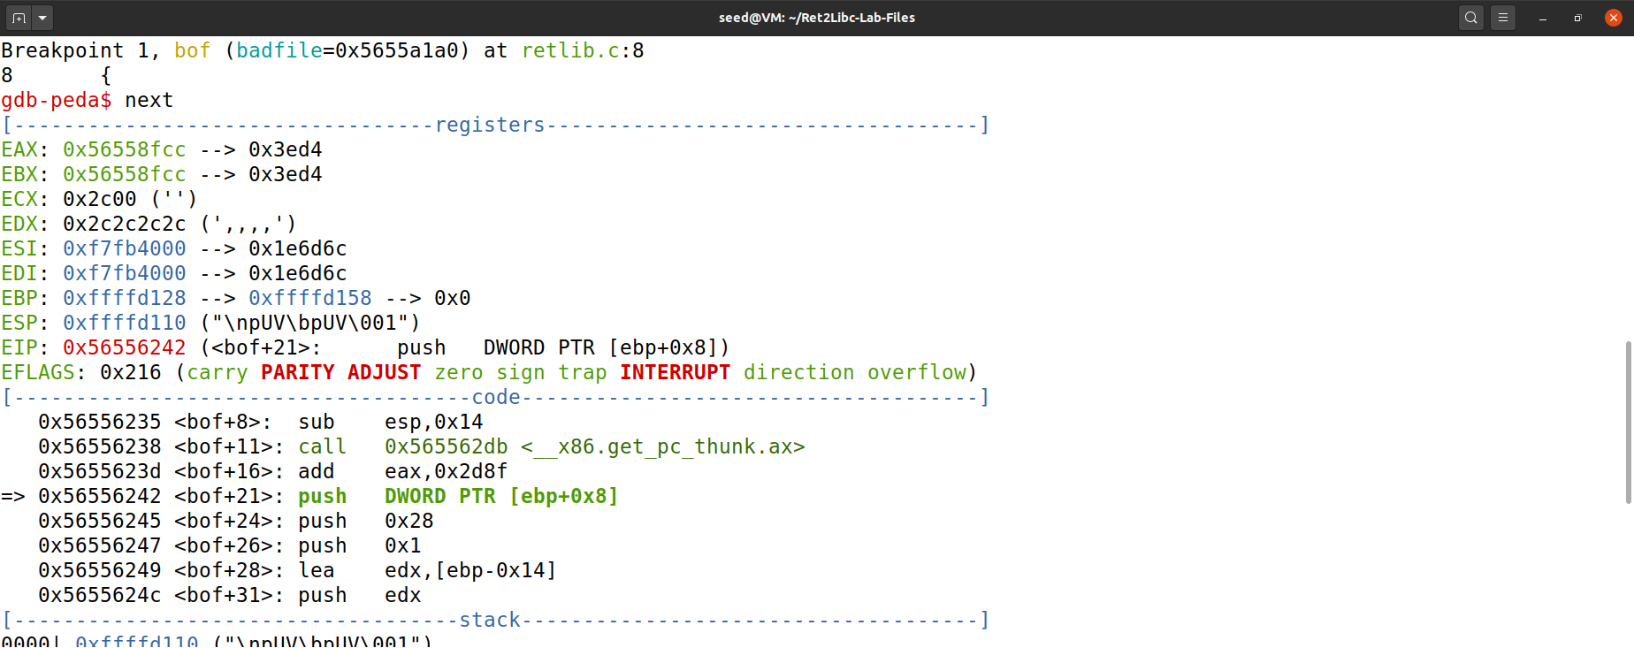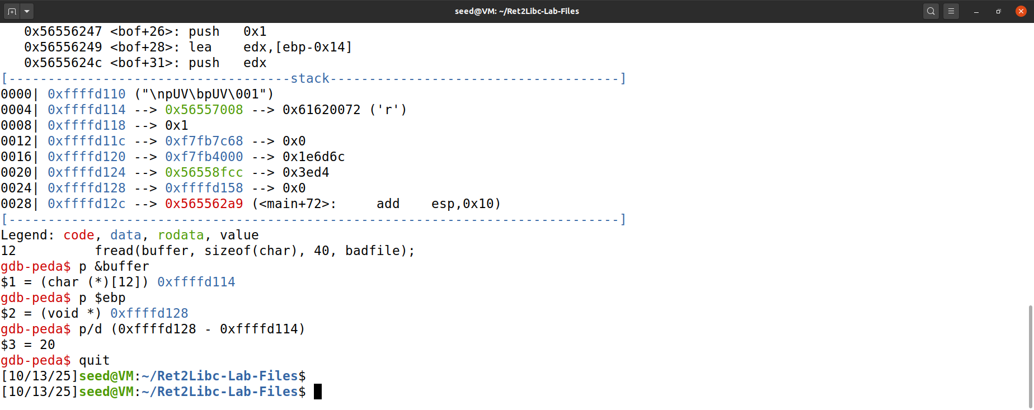

Task 8: Edit the file exploit.c as shown below, compile, and run it to generate "badfile" EXTREME CAUTION: make sure to edit these three lines using right values
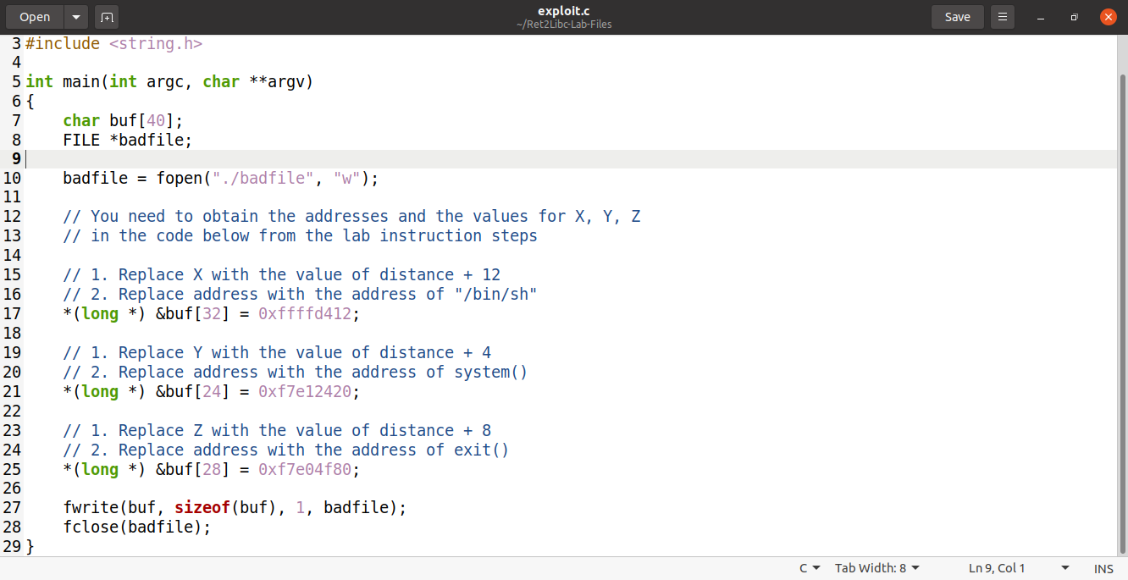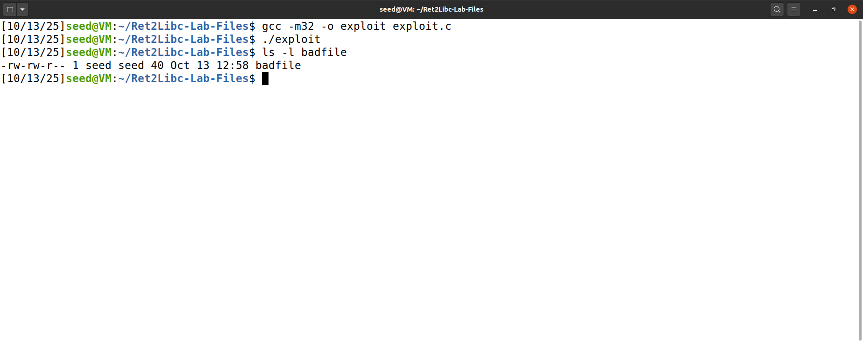

Task 9: Run the vulnerable program to see if it launches a root shell
